Manual of Instruction

Section Name: Structure & Organization Section Number: 3.08
Title: Organization Map

Description: New York State Women, Inc. is divided into regions

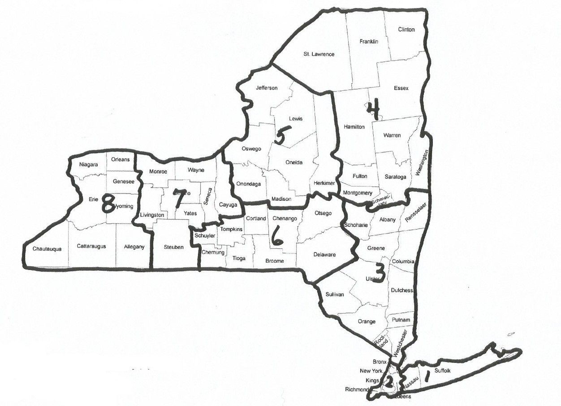

REGION “1” NASSAU, SUFFOLK
REGION “2” NEW YORK, BRONX, KINGS, QUEENS, RICHMOND;
REGION”3” ALBANY, COLUMBIA, GREENE, RENSSELEAR, SCHOHARIE, ULSTER, DUTCHESS, ORANGE, PUTNAM, ROCKLAND, WESTCHESTER, SULLIVAN;
REGION”4” FULTON, HAMILTON, MONTGOMERY, SARATOGA, SCHENECTADY, WARREN, WASHINGTON, CLINTON, ESSEX, FRANKLIN, ST. LAWRENCE;
REGION “5” HERKIMER, JEFFERSON, LEWIS, ONEIDA, ONONDAGA, OSWEGO, MADISON
REGION “6” BROOME, CHEMUNG, CHENANGO, CORTLAND, DELAWARE, OTSEGO, SCHUYLER, TIOGA, TOMPKINS; REGION “7” CAYUGA, LIVINGSTON, MONROE, ONTARIO, SENECA, STEUBEN, WAYNE, YATES;
REGION “8” ALLEGHENY, CATTARAUGUS, CHATAUTAUQUA, ERIE, GENESEE, NIAGARA, ORLEANS, WYOMING

Date of Board Approval: 3/3/2012 Effective Date: 7/1/2013

* Underlined passages denotes wording from the NYS Women, Inc. Bylaws Article VIII: Regional Organization, Section 1 and 2

